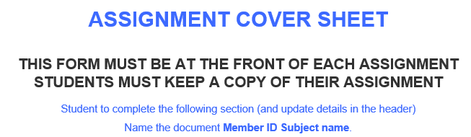
40100
Data Science Applications
29/09/2026
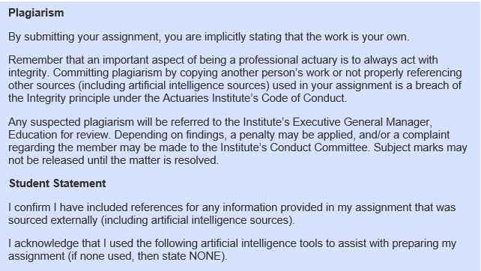
Tool | Purpose
Claude | Claude code was used throughout for code writing, debugging and commentary drafting.
Add rows as required

Video Link: https://youtu.be/x6STeEIJghc

